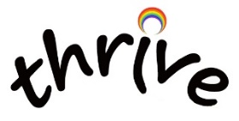
ADHD Support
- Foundation of non-pharmacological support
  - Daily appreciation of strengths: ‘What 3 things am I proud of today?’
  - Daily mindfulness: at least 10mins – Smiling Mind app
  - 4 pillars
    - Good regular food
    - Good sleep
    - Regular exercise: 30mins/day
    - Resonant breathing: at least 10mins/day – Breathe2Relax app (balances autonomic systems)

- Websites
  - http://www.add-vance.org/
  - www.angelssupportgroup.org.uk
  - https://www.drhallowell.com/adhd/adhd-resources/
  - https://www.understood.org
  - SPACE (https://spaceherts.org.uk/) is a charity in Hertfordshire who support children and young people and their families who have ASD, ADHD or other neurodiverse conditions.

- Healthier Together Hertfordshire Resources:
  - https://www.hwehealthiertogether.nhs.uk/health-for-young-people/mental-health-and-wellbeing/attention-deficit-hyperactivity-disorder-adhd
  - https://www.hwehealthiertogether.nhs.uk/parentscarers/children-complex-needs/support-advice-parents-neurodiversity
  - https://www.hwehealthiertogether.nhs.uk/parentscarers/support-advice-parents-send-services

- Books:
  - ‘Attention Girls’ by Patricia Quinn: ADHD for Girls 8-13yr

