Winter promotion of Herts and West Essex Healthier Together website
Tailored toolkit for HWE ICS
Background
The Healthier Together website was developed to provide parents with easily accessible information about common childhood illnesses including when and where to get help and to also offer support to healthcare professionals to make sure consistent messages are given to parents.
It includes close collaboration with professionals across health and social care (schools, local authorities, health visitors, school nurses, practice nurses, acute children’s community nurses, GPs, midwives, ambulance services and NHS 111).
With winter now in full swing, the aim of this toolkit is to continue to remind parents about this valuable resource. There was an earlier version which included newsletters and social media appropriate to autumn and has been updated to include more seasonal messages.
Key messages for parents
- It’s an online resource to help provide information to parents who have concerns about the health and wellbeing of their children
- Clear and trusted advice from local health care providers
- ‘One stop shop’ for information about common illnesses, ailments and injury
- Local and up to date information

Website

The following is shared on the HWE ICS website. You are welcome to replicate this text on your own site:

Template copy
Health advice all in one place for your family this winter

This winter, we’ve already experienced a bout of cold weather and freezing temperatures. This weather can bring lots of illnesses to our homes and make them spread more easily – from coughs and colds to sickness bugs.

It’s important to know where to turn if your family and loved ones become unwell, so you can stay safe and well this season.

With flu cases rising recently across Hertfordshire and west Essex, there is still time to check what vaccines your children and family may need and get the seasonal flu vaccine to protect against serious illness.

It can be a hugely worrying time to have poorly children and you will want to know what symptoms to look out for, get advice on what to do in the first instance and know when you need to call in professional help.

Clinical leaders of local health and care services have created a website you can go directly to which offers useful information and trusted advice direct from health professionals all in one place.

The Hertfordshire and west Essex Healthier Together website has up-to-date information, advice and guidance on a number of topics, including:

- sepsis
- jaundice
- looking after fever, coughs and colds
- accidents and injuries, including what to do if your child swallows a small object
- sickness bugs and when to keep your children at home
- vaccinations during pregnancy.

The site advises on the common symptoms of a number of conditions, what steps you should take to treat them at home and when to think about seeking further help.

Dr Rachel Joyce, Medical director for Herts and West Essex ICB, said: “It is sometimes hard to know what your next steps are when your children are unwell and what to look out for in those symptoms if they are normal or you should get extra medical help.

“This website gives parents that information about a range of childhood illnesses, all in one place and supplied by trusted health experts, to make that decision. It also has a range of information on important topics and places you can get extra support.”

Please share this website with your own friends and family this winter and help them get much needed support and advice for their own loved ones when they need it.

Newsletter articles

The following articles will be used by HWE ICB for internal and external newsletters, and you are encouraged to share these within your own similar publications:

Target audience | Template copy
Public newsletter (long version) | Get expert advice this winter with the Healthier Together website  This winter, we’ve already experienced a bout of cold weather and freezing temperatures. It can bring lots of illnesses to our homes – from coughs and colds to sickness bugs.  It’s important to know where to turn if your family and loved ones become unwell, so you can stay safe and well this season.  With flu cases rising recently across Hertfordshire and west Essex, there is still time to check what vaccines your children and family may need and get the seasonal flu vaccine to protect against serious illness.  There is a bespoke website, created by clinical leaders of local health and care services that can help with useful information and trusted advice, all in one place and directly from health professionals.  The Hertfordshire and west Essex Healthier Together website advises on the common symptoms of a number of childhood conditions, what steps you should take to treat them at home and when to think about getting further help.  This includes advice and guidance on:  - sepsis  - jaundice  - looking after fever, coughs and colds  - accidents and injuries, including what to do if your child swallows a small object  - sickness bugs and when to keep your children at home  - vaccinations during pregnancy.  Dr Rachel Joyce, Medical director for Herts and West Essex ICB, said: “It is sometimes hard to know what your next steps are when your children are unwell and what to look out for in those symptoms if they are normal or you should get extra medical help.  “This website gives parents that information about a range of common childhood illnesses, all in one place and supplied by trusted health experts, to make that decision. It also has a range of information on important topics and places you can get extra support.”  Please share this website with your own friends and family this winter and help them get much needed support and advice for their own loved ones when they need it.
Public newsletter (short version) | Winter can bring lots of illnesses to our homes – from coughs and colds to sickness bugs.  As a parent, you will want to know what symptoms to look out for across a range of childhood illnesses, what to do initially and when to seek professional help.  The Hertfordshire and west Essex Healthier Together website offers all this in one place.  Created by clinical leaders of local health and care services it has advice on a number of conditions including allergies, coughs and colds, childhood flu vaccinations and mental health concerns.  Dr Rachel Joyce, Medical director for Herts and West Essex ICB, said: “This website gives parents that information about a range of common childhood illnesses, all in one place and supplied by trusted health experts, to reassure you when dealing with your child’s symptoms. It also has a range of information on important topics and places you can get extra support.”  Please share this website with your friends and family this winter.
Staff newsletter | Tell your friends and family about the Healthier Together website  Knowing where to get the right advice, when we need it, all in one place can make a huge difference when our families are poorly.  Clinical leaders of local health and care services have created a website you can go directly to which offers useful information and trusted advice on a range of common childhood illnesses all in one place.  This winter, we want to continue to spread the word about the Hertfordshire and west Essex Healthier Together website which has up-to-date information, advice and guidance on a number of topics, including:  - sepsis  - jaundice  - looking after fever, coughs and colds  - accidents and injuries, including what to do if your child swallows a small object  - sickness bugs and when to keep your children at home  - vaccinations during pregnancy.  The site advises on the common symptoms of a number of conditions, what steps you should take to treat them at home and when to think about seeking further help.  Please help us by sharing this website with your friends and family this winter.

Social media

The following images will be shared on the Hertfordshire and West Essex ICB social media accounts. Download the images in full resolution (please do not save the images directly from this document) and share on your own channels.

The social media posts are aimed at parents of children and young people and therefore will be shared at times of the day when parents are most likely to be on social media. These are predicted to be:

- Before the school run – 6am to 7.30am
- Immediately before school pick up time – 2.30pm to 3.15pm
- In the evening – 8pm to 10pm

Social image and name | Accompanying copy | Alt text
Allergy rash  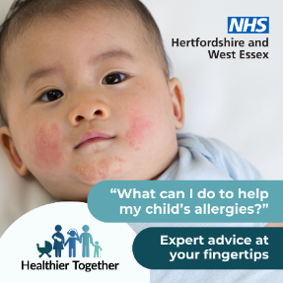 | Are you worried about your child’s allergies and what you can do to help? The Healthier Together website has a host of expert advice: https://www.hwehealthiertogether.nhs.uk/parentscarers/worried-your-child-unwell/allergies | A baby with a rash across their cheeks and chin.  Text says ‘What can I do to help my child’s allergies? Expert advice at your fingertips’
Bronchiolitis  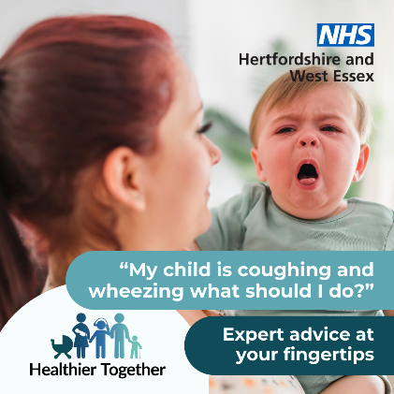 | Do you have concerns about your child’s breathing? Check signs and symptoms on the Healthier Together website to find out when to seek help: https://www.hwehealthiertogether.nhs.uk/parentscarers/worried-your-child-unwell/bronchiolitis | A parent holding their young child who has its mouth open and tongue slightly out.  Text says ‘My child is coughing and wheezing what should I do? Expert advice at your fingertips’
Childhood vaccination  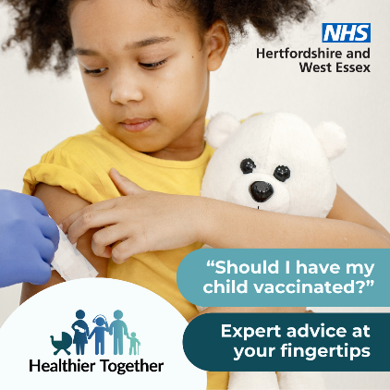 | Has your child been vaccinated to protect them from serious illness? The Healthier Together website has information about vaccinations you might need to help your family stay well: https://www.hwehealthiertogether.nhs.uk/parentscarers/keeping-your-child-safe-and-healthy/childhood-vaccinations-essential-information | A child cuddling a teddy bear looks down at her arm where she is being vaccinated.  Text says ‘Should I have my child vaccinated? Expert advice at your fingertips’
Fever  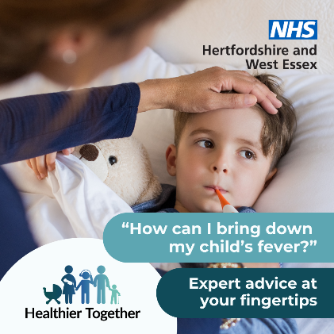 | Are you worried about your child’s high temperature? Find out what you should do next on the Healthier Together website: https://www.hwehealthiertogether.nhs.uk/parentscarers/worried-your-child-unwell/fever-high-temperature | A child lying in bed cuddling a teddy bear, while their parent checks his temperature.  Text says ‘How can I bring down my child’s fever? Expert advice at your fingertips’
Healthy pregnancy   | If you’re looking for ways to stay healthy during your pregnancy, the Healthier Together website provides advice and guidance from local midwives and health visitors on topics from eating healthy to exercise: https://www.hwehealthiertogether.nhs.uk/pregnant-women/staying-healthy-pregnancy | A pregnant woman standing sideways on with her vest slightly pulled up to show her bump.  Text says ‘How can I keep healthy during my pregnancy? Expert advice at your fingertips’
Jaundice  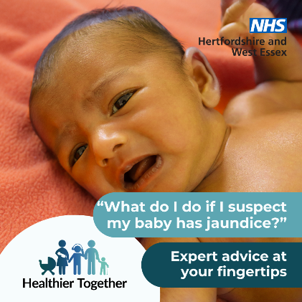 | If you suspect your baby has jaundice and are not sure what to do next, visit the Healthier Together website for advice on when and where to seek help: https://www.hwehealthiertogether.nhs.uk/parentscarers/worried-your-baby-unwell-under-3-months/jaundice | A baby lying on its back on a blanket.  Text says ‘What do I do if I suspect my baby has jaundice? Expert advice at your fingertips’
Pregnancy vaccinations  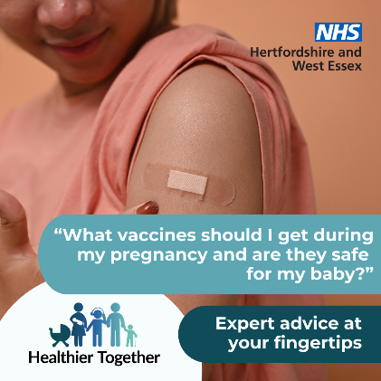 | Find out which vaccinations are recommended during pregnancy, to protect you and your baby from serious illnesses, by visiting the Healthier Together website: https://www.hwehealthiertogether.nhs.uk/pregnant-women/staying-healthy-pregnancy/vaccinations-pregnant-women | A person looking down at a plaster on their arm why they have been vaccinated.  Text says ‘What vaccines should I get during my pregnancy and are they safe for my baby? Expert advice at your fingertips’
School or nursery  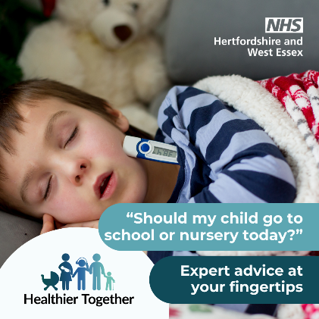 | Is your child feeling poorly? If you’re not sure if you should send them to school or nursery, check out the Healthier Together website for advice on lots of conditions: https://www.hwehealthiertogether.nhs.uk/parentscarers/child-unwell-ok-go-nurseryschool | A sleeping child in bed with a thermometer poking out of his pyjamas.  Text says ‘Should my child go to school or nursery today? Expert advice at your fingertips’
Sepsis  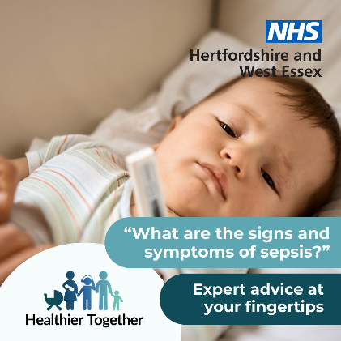 | Does your child have an infection and is feeling very unwell? Are you concerned it could be sepsis? Find out what to do next on the Healthier Together website: https://www.hwehealthiertogether.nhs.uk/parentscarers/worried-your-child-unwell/sepsis-spotting-signs | A baby lying down with a thermometer.  Text says ‘What are the signs and symptoms of sepsis? Expert advice at your fingertips’
Small batteries  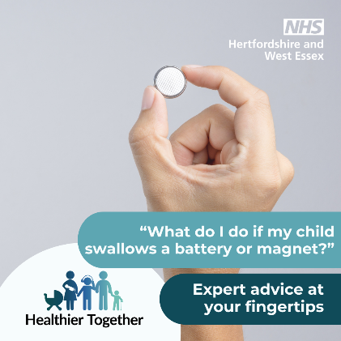 | Get advice on how to keep your child safe at home, including what to do if an accident or injury happens, by visiting the Healthier Together website: https://www.hwehealthiertogether.nhs.uk/parentscarers/worried-your-child-unwell/accidents-and-injuries-keeping-your-child-safe-home | A hand holding a small round battery.  Text says ‘What do I do if my child swallows a battery or magnet? Expert advice at your fingertips’
Visit website 1  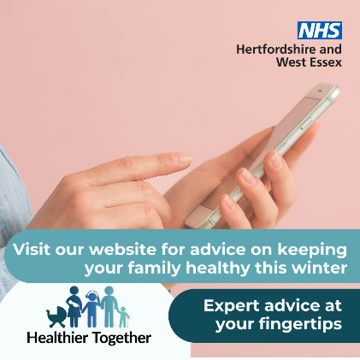 | If you have concerns about the health and wellbeing of your child(ren), the Healthier Together website offers useful information and trusted advice direct from local health professionals all in one place:  https://www.hwehealthiertogether.nhs.uk | A person holding a mobile phone.  Text says ‘Visit our website for advice on keeping your family healthy this winter. Expert advice at your fingertips’
Visit website 2  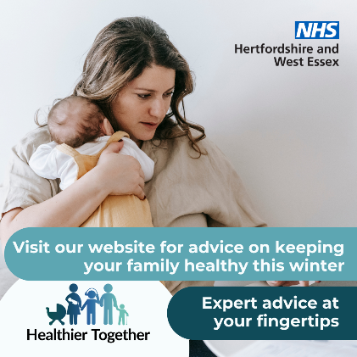 | If you’re a parent and want to know what symptoms to look out for across a range of childhood illnesses, what to do in the first instance and when to seek professional help, visit the Healthier Together website:  https://www.hwehealthiertogether.nhs.uk | A woman holding a baby against her chest.  Text says ‘Visit our website for advice on keeping your family healthy this winter. Expert advice at your fingertips’

Digital screens

Upload onto public digital screens, such as waiting rooms. Download these digital screens in full resolution (please do not save these images directly from this document).

GP screen winter snowflakes | 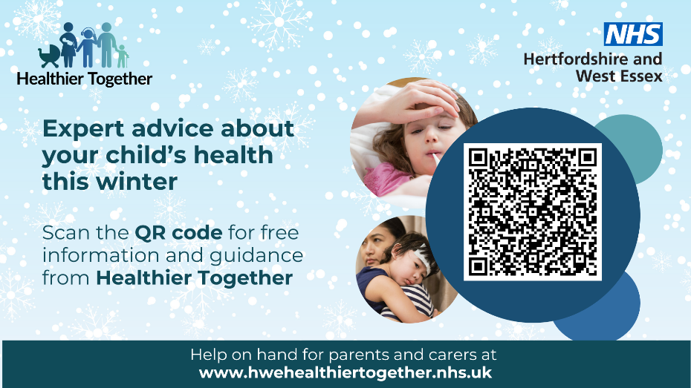
GP screen winter 2 | 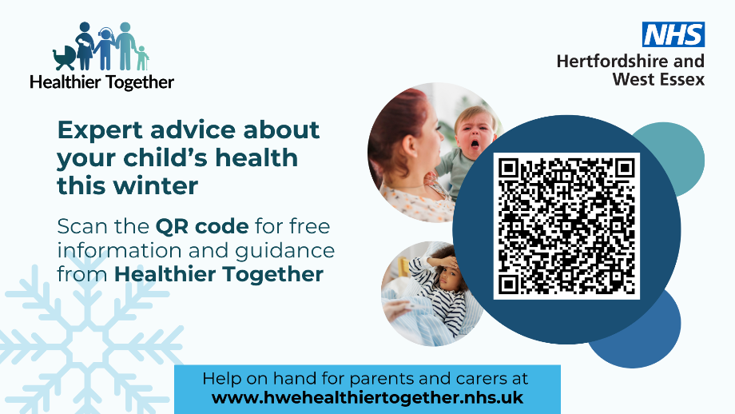
GP screen pregnancy | 