Autumn promotion of Herts and West Essex Healthier Together website
Tailored toolkit for HWE ICS
Background
The Healthier Together website was developed to provide parents with easily accessible information about common childhood illnesses including when and where to get help and to also offer support to healthcare professionals to make sure consistent messages are given to parents.
It includes close collaboration with professionals across health and social care (schools, local authorities, health visitors, school nurses, practice nurses, acute children’s community nurses, GPs, midwives, ambulance services and NHS 111).
With autumn now well underway, the aim of this toolkit is to continue to remind parents about this valuable resource. There was an earlier version which included newsletters and social media appropriate to summer and has been updated to include more seasonal messages.
Key messages for parents
- It’s an online resource to help provide information to parents who have concerns about the health and wellbeing of their children
- Clear and trusted advice from local health care providers
- ‘One stop shop’ for information about common illnesses, ailments and injury
- Local and up to date information

Website

The following is shared on the HWE ICS websites. You are welcome to replicate this text on your own site:

Template copy
Health advice all in one place for your family this autumn

While the arrival of autumn with its darker nights and cooler temperatures usually marks the start of the build up to Christmas and other festivities, it’s important to remember that typically at this time of year we start to see an increase in coughs and colds with infections also on the rise.

In preparation for winter, now is a good time to encourage parents and carers to check what vaccines their children and families may need and to take up the offer of the seasonal flu vaccine to protect against serious illness.

For those families who are expecting a baby, knowing how to stay healthy during pregnancy, including getting the RSV vaccination when pregnant, is just one of the ways to protect babies from a serious lung infection.

It can be a hugely worrying time for parents to have poorly children and they will want to know what symptoms to look out for, get advice on what to do in the first instance and know when they need to call in professional help.

Clinical leaders of local health and care services have created a website you can go directly to which offers useful information and trusted advice direct from health professionals all in one place.

The Hertfordshire and west Essex Healthier Together website has up-to-date information, advice and guidance on a number of topics, including:

- childhood vaccinations
- oral health
- childhood and teen anxiety
- asthma
- infectious diseases, including measles
- pregnancy and birth, including advice on common concerns during pregnancy and staying healthy in pregnancy.

The site advises on the common symptoms of a number of conditions, what steps you should take to treat them at home and when to think about seeking further help.

Professionals also use this website for information to share during appointments.

Dr Rachel Joyce, Medical director for Herts and West Essex ICB, said: “It is sometimes hard to know what your next steps are when your children are unwell and what to look out for in those symptoms if they are normal or you should get extra medical help.

“This website gives parents that information about a range of childhood illnesses, all in one place and supplied by trusted health experts, to make that decision. It also has a range of information on important topics and places you can get extra support.”

Please share this website with your own friends and family this autumn and help them get much needed support and advice for their own loved ones when they need it.

Newsletter articles

The following articles will be used by HWE ICB for internal and external newsletters, and you are encouraged to share these within your own similar publications:

Target audience | Template copy
Public newsletter (long version) | Get expert advice this autumn with the Healthier Together website  While the arrival of autumn with its darker nights and cooler temperatures usually marks the start of the build up to Christmas and other festivities, it’s important to remember that typically at this time of year we start to see an increase in coughs and colds with infections also on the rise.  In preparation for winter, now is a good time to encourage parents and carers to check what vaccines their children and families may need and to take up the offer of the seasonal flu vaccine to protect against serious illness.  For those families who are expecting a baby, knowing how to stay healthy during pregnancy, including getting the RSV vaccination when pregnant, is just one of the ways to protect babies from a serious lung infection.  There is a bespoke website, created by clinical leaders of local health and care services that can help with useful information and trusted advice, all in one place and directly from health professionals.  The Hertfordshire and west Essex Healthier Together website advises on the common symptoms of a number of childhood conditions, what steps you should take to treat them at home and when to think about getting further help.  This includes advice and guidance on:  - childhood vaccinations  - oral health  - childhood and teen anxiety  - asthma  - infectious diseases, including measles  - pregnancy and birth, including advice on common concerns during pregnancy and staying healthy in pregnancy.  Professionals also use this website for information to share during appointments.  Dr Rachel Joyce, Medical director for Herts and West Essex ICB, said: “It is sometimes hard to know what your next steps are when your children are unwell and what to look out for in those symptoms if they are normal or you should get extra medical help.  “This website gives parents that information about a range of common childhood illnesses, all in one place and supplied by trusted health experts, to make that decision. It also has a range of information on important topics and places you can get extra support.”  Please share this website with your own friends and family this autumn and help them get much needed support and advice for their own loved ones when they need it.
Public newsletter (short version) | There is definitely an autumnal feel to the weather right now with cooler temperatures, so it’s important to remember some of the challenges this new season can bring – in the run up to winter – to our family’s health.  As a parent, you will want to know what symptoms to look out for across a range of childhood illnesses, what to do initially and when to seek professional help.  The Hertfordshire and west Essex Healthier Together website offers all this in one place.  Created by clinical leaders of local health and care services it has advice on a number of conditions including mental health concerns, particularly around the lead up to exams and dealing with allergies including hay fever.  Dr Rachel Joyce, Medical director for Herts and West Essex ICB, said: “This website gives parents that information about a range of common childhood illnesses, all in one place and supplied by trusted health experts, to reassure you when dealing with your child’s symptoms. It also has a range of information on important topics and places you can get extra support.”  Please share this website with your friends and family this autumn.
Staff newsletter | Tell your friends and family about the Healthier Together website  Knowing where to get the right advice, when we need it, all in one place can make a huge difference when our families are poorly.  Clinical leaders of local health and care services have created a website you can go directly to which offers useful information and trusted advice on a range of common childhood illnesses all in one place.  This autumn, we want to continue to spread the word about the Hertfordshire and west Essex Healthier Together website which has up-to-date information, advice and guidance on a number of topics, including:  - childhood vaccinations  - oral health  - childhood and teen anxiety  - asthma  - infectious diseases, including measles  - pregnancy and birth, including advice on common concerns during pregnancy and staying healthy in pregnancy.  The site advises on the common symptoms of a number of conditions, what steps you should take to treat them at home and when to think about seeking further help.  Please help us by sharing this website with your friends and family this autumn.
Social media

The following images will be shared on the Hertfordshire and West Essex ICB social media accounts. Download the images in full resolution (please do not save the images directly from this document) and share on your own channels.

The social media posts are aimed at parents of children and young people and therefore will be shared at times of day when parents are most likely to be on social media. These are predicted to be:

- Before the school run – 6am to 7.30am
- Immediately before school pick up time – 2.30pm to 3.15pm
- In the evening – 8pm to 10pm

Social image and name | Accompanying copy | Alt text
Autumn vaccines 1  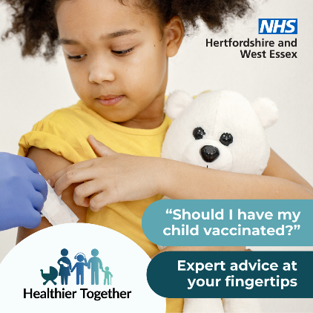 | Has your child been vaccinated to protect them from serious illness? The Healthier Together website has information about vaccinations you might need to help your family stay well: https://www.hwehealthiertogether.nhs.uk/parentscarers/keeping-your-child-safe-and-healthy/childhood-vaccinations-essential-information | Child cuddling a teddy bear looks down at her arm where she is being vaccinated.  Text reads: “Should I have my child vaccinated?”  “Expert advice at your fingertips”
Autumn vaccines 2  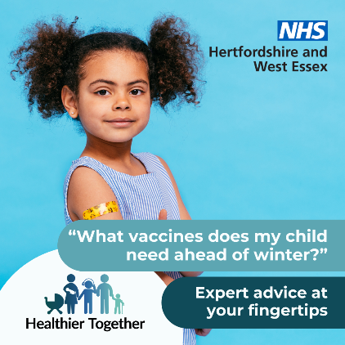 | Are your child’s vaccines up to date? Visit the Healthier Together website to find out how to protect your family against nasty infections and illness: https://www.hwehealthiertogether.nhs.uk/parentscarers/keeping-your-child-safe-and-healthy/childhood-vaccinations-essential-information | Child proudly showing a plaster on her arm where she has been vaccinated.  Text reads: “What vaccines does my child need ahead of winter?”  “Expert advice at your fingertips”
Strep A  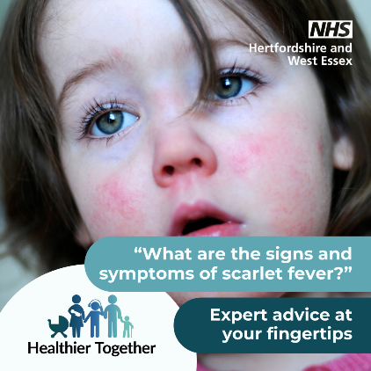 | Is your child feeling poorly? Are you concerned it could be scarlet fever? Find out what you should do next on the Healthier Together website: https://www.hwehealthiertogether.nhs.uk/parentscarers/worried-your-child-unwell/scarlet-fever | Child with wide eyes and rosy cheeks.  Text reads: “What are the signs and symptoms of scarlet fever?”  “Expert advice at your fingertips”
Oral health 1  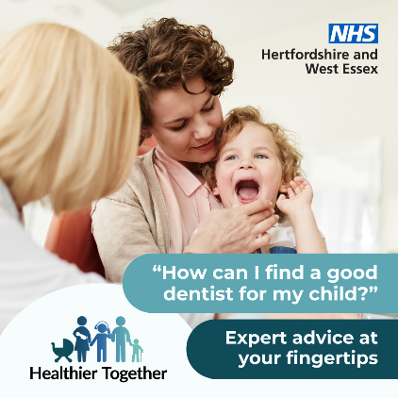 | Do you have concerns about your child’s teeth and how to take good care of them? Find top tips and advice about taking your child to the dentist on the Healthier Together website: https://www.hwehealthiertogether.nhs.uk/parentscarers/keeping-your-child-safe-and-healthy/oral-health | Child with their mouth open next to their parent, with a dentist who has their hand on the child’s chin.  Text reads: “How can I find a good dentist for my child?”  “Expert advice at your fingertips”
Oral health 2  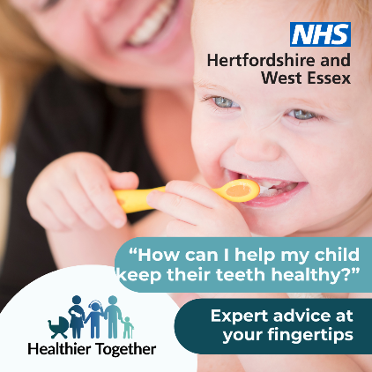 | Are you worried about how to take good care of your child’s teeth? Visit the Healthier Together website for top tips on brushing and how you can keep their teeth decay-free: https://www.hwehealthiertogether.nhs.uk/parentscarers/keeping-your-child-safe-and-healthy/oral-health | Child cleaning their teeth with a toothbrush while their parent looks on.  Text reads: “How can I help my child keep their teeth healthy?”  “Expert advice at your fingertips”
Pregnancy 1  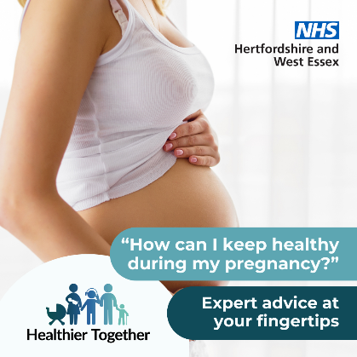 | If you’re looking for ways to stay healthy during your pregnancy, the Healthier Together website provides advice and guidance from local midwives and health visitors on topics from eating healthy to exercise: https://www.hwehealthiertogether.nhs.uk/pregnant-women/staying-healthy-pregnancy | Pregnant woman standing sideways on with her vest slightly pulled up to show her bump.  Text reads: “How can I keep healthy during my pregnancy?”  “Expert advice at your fingertips”
Pregnancy 2  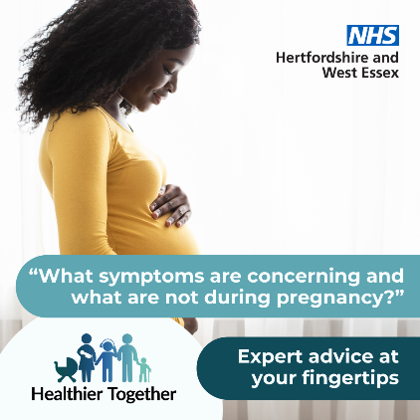 | Do you have worries about your pregnancy? Get advice on some of the common concerns during pregnancy, including when and how to seek help, by visiting the Healthier Together website: https://www.hwehealthiertogether.nhs.uk/pregnant-women/worried-you-are-unwell-during-pregnancy | Pregnant woman standing sideways on with her hand on her bump.  Text reads: “What symptoms are concerning and what are not during pregnancy?”  “Expert advice at your fingertips”
Allergy rash  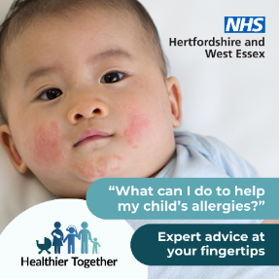 | Are you worried about your child’s allergies and what you can do to help?  The Healthier Together website has a host of expert advice: https://www.hwehealthiertogether.nhs.uk/parentscarers/worried-your-child-unwell/allergies | Baby with a rash across their cheeks and chin.  Text says: “What can I do to help my child’s allergies?”  “Expert advice at your fingertips”
Anxious child  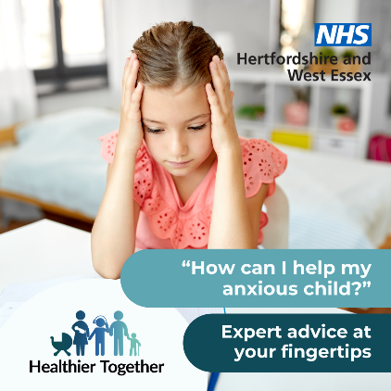 | Is your child suffering from anxiety? The Healthier Together website offers useful information and top tips on what to do about it, along with where to get advice and support locally: https://www.hwehealthiertogether.nhs.uk/health-for-young-people/mental-health-and-wellbeing/anxiety | Child sitting at a desk with their head in their hands looking down.  Text says: “How can I help my anxious child?”  “Expert advice at your fingertips”
Measles 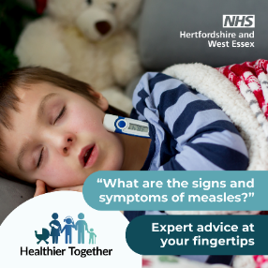 | Is your child feeling poorly? Are you concerned it could be measles? Find out what to do next on the Healthier Together website: https://www.hwehealthiertogether.nhs.uk/parentscarers/worried-your-child-unwell/measles | Sleeping child in bed with a thermometer poking out of his pyjamas.  Text says: “What are the signs and symptoms of measles?”  “Expert advice at your fingertips”
Visit website 1  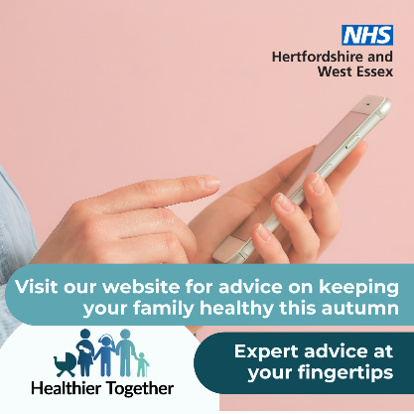 | If you have concerns about the health and wellbeing of your child(ren), the Healthier Together website offers useful information and trusted advice direct from local health professionals all in one place:  https://www.hwehealthiertogether.nhs.uk | Person holding a mobile phone.  Text says ‘Visit our website for advice on keeping your family healthy this autumn. Expert advice at your fingertips’
Visit website 2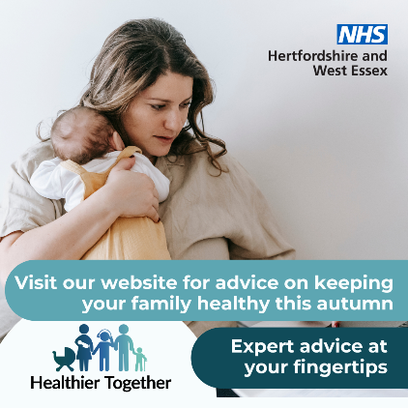 | If you’re a parent and want to know what symptoms to look out for across a range of childhood illnesses, what to do in the first instance and when to seek professional help, visit the Healthier Together website:  https://www.hwehealthiertogether.nhs.uk | Woman holding a baby against her chest.  Text says ‘Visit our website for advice on keeping your family healthy this autumn. Expert advice at your fingertips’
Digital screens

Upload onto public digital screens, such as waiting rooms. Download these digital screens in full resolution (please do not save these images directly from this document).

GP screen – child’s health 1  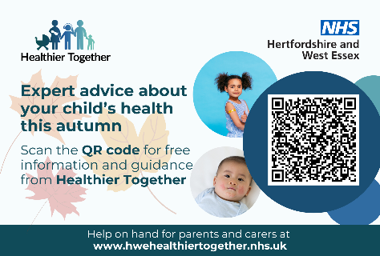 | GP screen – child’s health 2  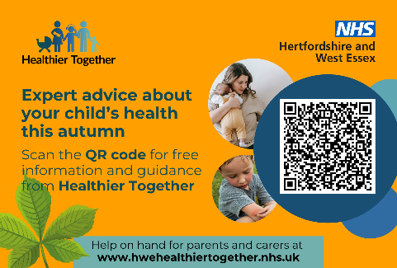 | GP screen - pregnancy  