Social media

The following images will be shared on the Hertfordshire and West Essex ICB social media accounts. Download the images in full resolution (please do not save the images directly from this document) and share on your own channels.

The social media posts are aimed at parents of children and young people and therefore will be shared at times of day when parents are most likely to be on social media. These are predicted to be:

- Before the school run – 6am to 7.30am
- Immediately before school pick up time – 2.30pm to 3.15pm
- In the evening – 8pm to 10pm

Social image and name | Accompanying copy | Alt text
Autumn vaccines 1  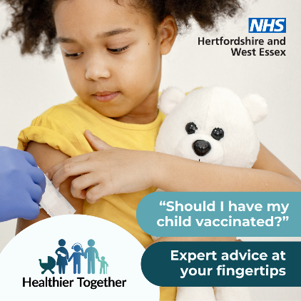 | Has your child been vaccinated to protect them from serious illness? The Healthier Together website has information about vaccinations you might need to help your family stay well: https://www.hwehealthiertogether.nhs.uk/parentscarers/keeping-your-child-safe-and-healthy/childhood-vaccinations-essential-information | Child cuddling a teddy bear looks down at her arm where she is being vaccinated.  Text reads: “Should I have my child vaccinated?”  “Expert advice at your fingertips”
Autumn vaccines 2  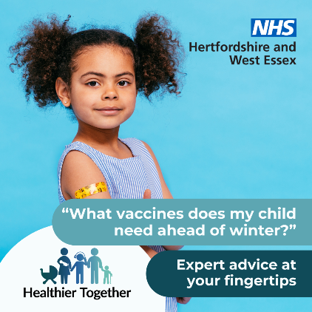 | Are your child’s vaccines up to date? Visit the Healthier Together website to find out how to protect your family against nasty infections and illness: https://www.hwehealthiertogether.nhs.uk/parentscarers/keeping-your-child-safe-and-healthy/childhood-vaccinations-essential-information | Child proudly showing a plaster on her arm where she has been vaccinated.  Text reads: “What vaccines does my child need ahead of winter?”  “Expert advice at your fingertips”
Strep A  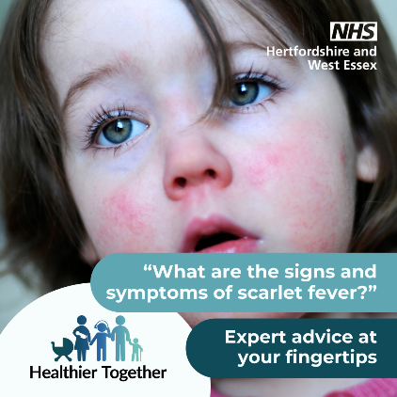 | Is your child feeling poorly? Are you concerned it could be scarlet fever? Find out what you should do next on the Healthier Together website: https://www.hwehealthiertogether.nhs.uk/parentscarers/worried-your-child-unwell/scarlet-fever | Child with wide eyes and rosy cheeks.  Text reads: “What are the signs and symptoms of scarlet fever?”  “Expert advice at your fingertips”
Oral health 1  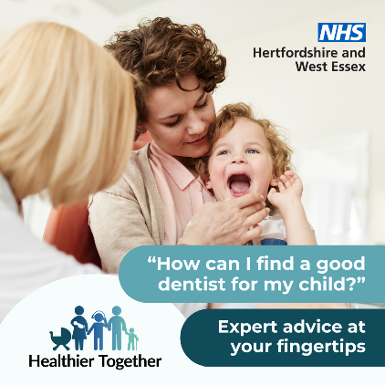 | Do you have concerns about your child’s teeth and how to take good care of them? Find top tips and advice about taking your child to the dentist on the Healthier Together website: https://www.hwehealthiertogether.nhs.uk/parentscarers/keeping-your-child-safe-and-healthy/oral-health | Child with their mouth open next to their parent, with a dentist who has their hand on the child’s chin.  Text reads: “How can I find a good dentist for my child?”  “Expert advice at your fingertips”
Oral health 2  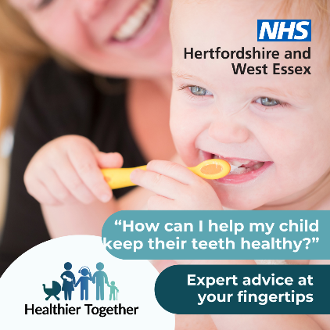 | Are you worried about how to take good care of your child’s teeth? Visit the Healthier Together website for top tips on brushing and how you can keep their teeth decay-free: https://www.hwehealthiertogether.nhs.uk/parentscarers/keeping-your-child-safe-and-healthy/oral-health | Child cleaning their teeth with a toothbrush while their parent looks on.  Text reads: “How can I help my child keep their teeth healthy?”  “Expert advice at your fingertips”
Pregnancy 1  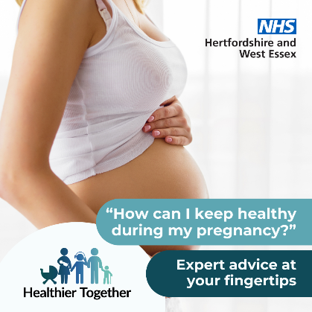 | If you’re looking for ways to stay healthy during your pregnancy, the Healthier Together website provides advice and guidance from local midwives and health visitors on topics from eating healthy to exercise: https://www.hwehealthiertogether.nhs.uk/pregnant-women/staying-healthy-pregnancy | Pregnant woman standing sideways on with her vest slightly pulled up to show her bump.  Text reads: “How can I keep healthy during my pregnancy?”  “Expert advice at your fingertips”
Pregnancy 2  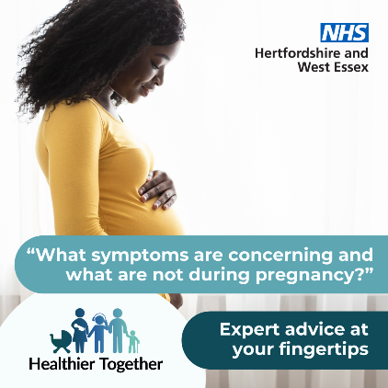 | Do you have worries about your pregnancy? Get advice on some of the common concerns during pregnancy, including when and how to seek help, by visiting the Healthier Together website: https://www.hwehealthiertogether.nhs.uk/pregnant-women/worried-you-are-unwell-during-pregnancy | Pregnant woman standing sideways on with her hand on her bump.  Text reads: “What symptoms are concerning and what are not during pregnancy?”  “Expert advice at your fingertips”
Allergy rash  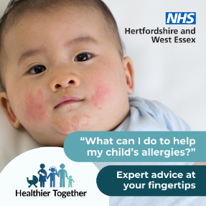 | Are you worried about your child’s allergies and what you can do to help?  The Healthier Together website has a host of expert advice: https://www.hwehealthiertogether.nhs.uk/parentscarers/worried-your-child-unwell/allergies | Baby with a rash across their cheeks and chin.  Text says: “What can I do to help my child’s allergies?”  “Expert advice at your fingertips”
Anxious child  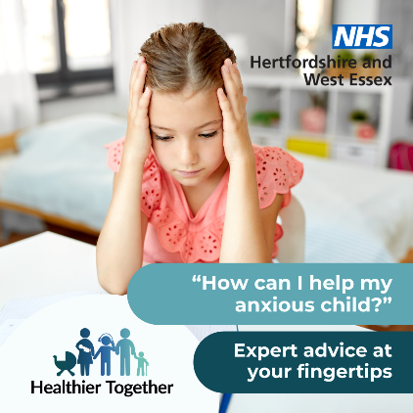 | Is your child suffering from anxiety? The Healthier Together website offers useful information and top tips on what to do about it, along with where to get advice and support locally: https://www.hwehealthiertogether.nhs.uk/health-for-young-people/mental-health-and-wellbeing/anxiety | Child sitting at a desk with their head in their hands looking down.  Text says: “How can I help my anxious child?”  “Expert advice at your fingertips”
Measles 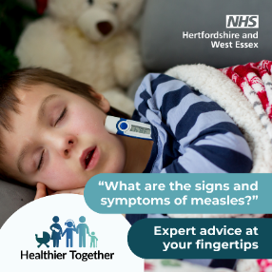 | Is your child feeling poorly? Are you concerned it could be measles? Find out what to do next on the Healthier Together website: https://www.hwehealthiertogether.nhs.uk/parentscarers/worried-your-child-unwell/measles | Sleeping child in bed with a thermometer poking out of his pyjamas.  Text says: “What are the signs and symptoms of measles?”  “Expert advice at your fingertips”
Visit website 1  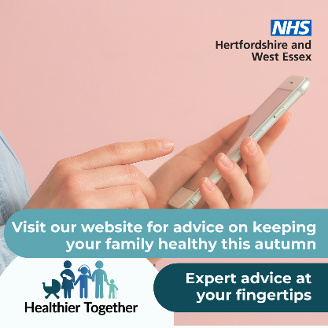 | If you have concerns about the health and wellbeing of your child(ren), the Healthier Together website offers useful information and trusted advice direct from local health professionals all in one place:  https://www.hwehealthiertogether.nhs.uk | Person holding a mobile phone.  Text says ‘Visit our website for advice on keeping your family healthy this autumn. Expert advice at your fingertips’
Visit website 2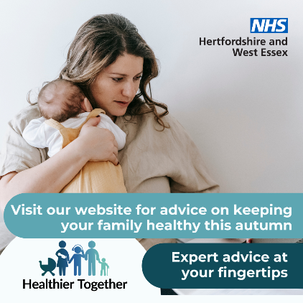 | If you’re a parent and want to know what symptoms to look out for across a range of childhood illnesses, what to do in the first instance and when to seek professional help, visit the Healthier Together website:  https://www.hwehealthiertogether.nhs.uk | Woman holding a baby against her chest.  Text says ‘Visit our website for advice on keeping your family healthy this autumn. Expert advice at your fingertips’

