Social media
The following images will be shared on the Hertfordshire and West ICB and ICS social media accounts. Download the images in full resolution (please do not save the images directly from this document) and share on your own channels.
The social media posts are aimed at parents of children and young people and therefore will be shared at times of day when parents are most likely to be on social media. These are predicted to be:
- Before the school run – 6-7.30am
- Immediately before school pick up time – 2.30-3.15pm
- In the evening – 8-10pm
Social image and name | Accompanying copy | Alt text
Allergies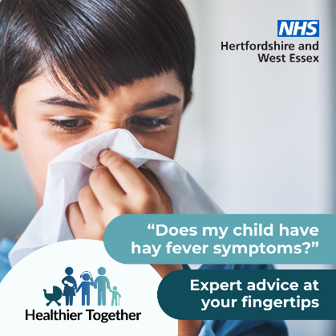 | Need advice to help your child manage their allergies? The Healthier Together website has guidance and tools to support you. Visit for details and other advice to help your family stay well:  https://tinyurl.com/usdskb73 | Child holding a tissue over their face and mouth. Text says: “Does my child have hay fever symptoms?”  “Expert advice at your fingertips”
Allergies - hayfever  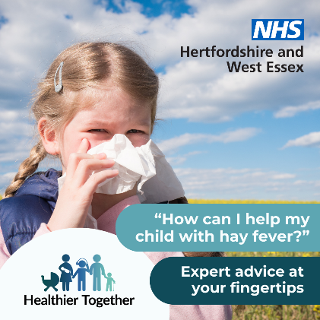 | Is your child suffering from Hay Fever? The Healthier Together website has a host of expert advice on how you can help with the symptoms: https://tinyurl.com/usdskb73 | Child with a tissue over their nose:  Text says: “How can I help my child with hay fever?”
Allergies – rash 1  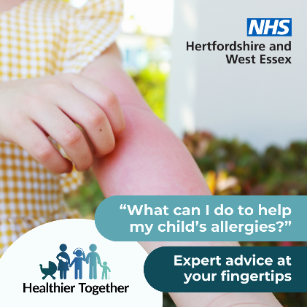 | Does your child have an itchy rash you think could be an allergy? The Healthy Together website has a host of expert information and advice: https://tinyurl.com/usdskb73 | A child in a yellow dress scratches one arm with the other hand, where there is a red, raised rash.  Text says: “What can I do to help my child’s allergies”  Expert advice at your fingertips”
Allergies – rash 2  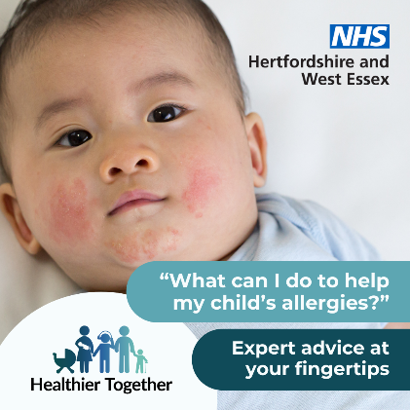 | Are you worried about your child’s allergies and what you can do to help?  The Healthier Together website has a host of expert advice:  https://tinyurl.com/usdskb73 | Baby with a rash across their cheeks.  Text says: “What can I do to help my child’s allergies?”  “Expert advice at your fingertips”
Exam stress  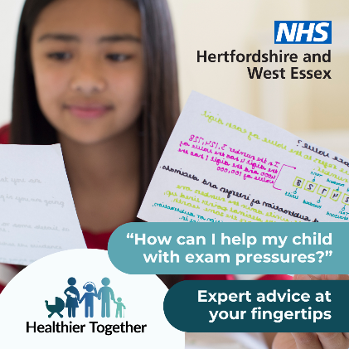 | Is your child getting ready to take exams? The Healthier Together website has expert advice on supporting your child during this time:  https://tinyurl.com/5n94r2wh | Teenager holds a number of different pieces of paper with school work in colourful writing.  Text says: “How can I help my child with exam pressures”  “Expert advice at your fingertips.”
Measles 1 | Is your child feeling poorly? Are you concerned it could be measles? Find out what to do next on the Healthier Together website:  https://tinyurl.com/yc4vdxd9
Measles 2  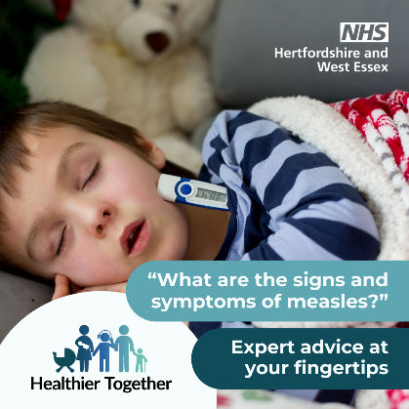 | If you think your child or another family member has measles, please call your GP practice or NHS 111 first before making a journey and visit the Healthier Together website to find out what the signs and symptoms are:  https://tinyurl.com/yc4vdxd9 | Sleeping child in bed with a thermometer poking out of his pyjamas.  Text says: What are the signs and symptoms of measles?”
Vaccinations  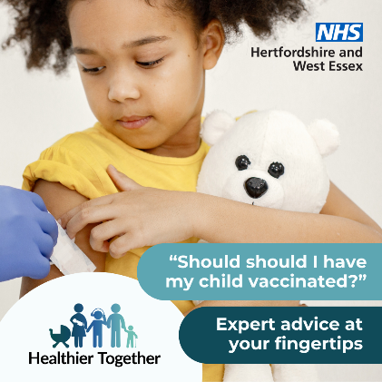 | Want to find out more about vaccinations for your child and why they are so important? The Healthier Together website has expert advice for you:  https://tinyurl.com/2rtz4dnz | Child cuddling a teddy bear looks down at her arm where she is being vaccinated.  Text reads: “Should I have my child vaccinated?”  “expert advice at your fingertips

