***Social media***

The following images will be shared on the Hertfordshire and West ICB and ICS social media accounts. [Download the images in full resolution](https://hertsandwestessex.icb.nhs.uk/downloads/download/95/healthier-together-website-promotion) *(please do not save the images directly from this document*) and share on your own channels.

The social media posts are aimed at parents of children and young people and therefore will be shared at times of day when parents are most likely to be on social media. These are predicted to be:

* Before the school run – 6-7.30am
* Immediately before school pick up time – 2.30-3.15pm
* In the evening – 8-10pm

|  |  |  |
| --- | --- | --- |
| **Social image and name** | **Accompanying copy** | **Alt text** |
| Asthma | Need advice to help your child manage their asthma? The Healthier Together website has guidance and tools to support you. Visit for details and other advice to help your family stay well: <https://tinyurl.com/2u83e4xh> | Child sitting upright in bed using a purple inhaler with a spacer. Text says: “How can I help my child manage their asthma?” Expert advice at your fingertips. |
| Coughs and Colds | Is your child a bit under the weather and you’re not sure if they should go to school? Find the answer to this and more, including expert advice to help your family stay well, on the Healthier Together website: <https://tinyurl.com/yn6re6yj> | Tween sitting down whilst blowing his nose. Text says: “Should my child go to school today?” Expert advice at your fingertips. |
| Conjunctivitis | Has your child woken up with sticky eye and you’re not sure what to do? Find out what steps to take and other advice to help your family stay well on the Healthier Together website: <https://tinyurl.com/mr2dduxx> | Baby with conjunctivitis. Text says: “Should my child go to nursery today?” Expert advice at your fingertips. |
| Norovirus | Has a dreaded stomach bug entered your household and you’re not sure what to do? Find out what steps to take and other advice to help your family stay well on the Healthier Together website: <https://tinyurl.com/36jah5e7> | Tween holding their stomach whilst their parent places her hand over it in comfort. Text says: “Should I be worried?” Expert advice at your fingertips. |
| Fever and high temperature 1 | Is your child unwell and are you worried? The Healthier Together website has expert advice on what to look out for and steps you should take: <https://tinyurl.com/mv6u9hb5> | Parent placing hand on the forehead of their child who sits beside them on the sofa. Text says: “When should I think about seeking help?” Expert advice at your fingertips. |
| Fever and high temperature 2 | Has your child got a temperature and you’re not sure what to do? Find out what steps to take and other advice to help your family stay well on the Healthier Together website: <https://tinyurl.com/mv6u9hb5> | Child lying in bed whilst they have their temperature taken. Text says: “What steps should I take to treat them at home?” Expert advice at your fingertips. |
| New parent | Parent or carer of a new-born? Visit the Healthier Together website for expert advice on what's normal and what's not for your baby: <https://tinyurl.com/4j84hny3> | Birthing parent holding new baby who is wrapped in a blanket. They are on a hospital bed. Text says: “What should I look out for as a new parents?” Expert advice at your fingertips. |
| Pregnancy headache | Unsure if the symptoms you're experiencing during pregnancy are normal? The Healthier Together website has expert advice on what to look out for and what steps you should take: <https://tinyurl.com/yxyzdesa> | Pregnant person holding their stomach with one hand and forehead with another. They are sitting on a sofa. Text says: “Should I be concerned about these symptoms?” Expert advice at your fingertips. |
| Pregnancy symptoms | Concerned about your symptoms during pregnancy? The Healthier Together website has expert advice on what to look out for and what steps you should take: <https://tinyurl.com/yxyzdesa> | Close-up of pregnant person holding their bump whilst they are sitting on the sofa. Text says: “Is this normal during pregnancy?” Expert advice at your fingertips. |

***Digital screens***

Upload onto public digital screens, such as waiting rooms. [Download these digital screens in full resolution](https://hertsandwestessex.icb.nhs.uk/downloads/download/95/healthier-together-website-promotion) *(please do not save the images directly from this document*).

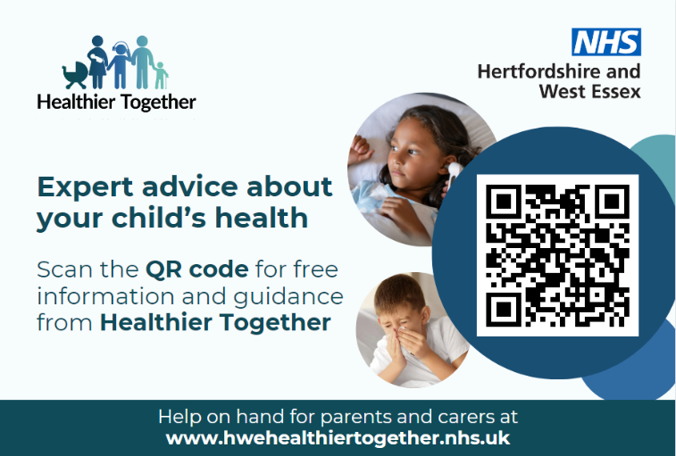

***Posters***

Posters for display in public spaces such as waiting rooms. [Download these posters in full resolution](https://hertsandwestessex.icb.nhs.uk/downloads/download/95/healthier-together-website-promotion) *(please do not save the images directly from this document*).

