**Promotion of Herts and West Essex Healthier Together website – tailored toolkit for HWE ICS**

**Background**

The Healthier Together website was developed to provide parents with easily accessible information about common childhood illnesses including when and where to get help and to also offer support to healthcare professionals to make sure consistent messages are given to parents.

It includes close collaboration with professionals across health and social care (schools, local authorities, health visitors, school nurses, practice nurses, acute children’s community nurses, GPs, midwives, ambulance services and NHS 111).

As winter approaches, the aim of this toolkit is to remind parents about this valuable resource.

**Key messages for parents**

* It’s an online resource to help provide information to parents who have concerns about the health and wellbeing of their children
* Clear and trusted advice from local health care providers.
* ‘One stop shop’ for information about common illnesses, ailments and injury
* Local and up to date information

***Webpages***

*The following is shared on the HWE ICB and ICS websites. You are welcome to replicate this text on your own site:*

|  |
| --- |
| ***Template copy*** |
| **Health advice all in one place for your family this winter**  Winter can bring lots of illnesses to our homes – from coughs and colds to sickness bugs.  It can be a hugely worrying time for parents to have poorly children and they will want to know what symptoms to look out for, get advice on what to do in the first instance and know when they need to call in professional help.  Clinical leaders of local health and care services have created a website you can go directly to which offers useful information and trusted advice direct from health professionals all in one place.  The [Hertfordshire and west Essex Healthier Together website](https://www.hwehealthiertogether.nhs.uk/?utm_source=HT+promotion&utm_medium=website+news&utm_campaign=HT+promotion&utm_id=HT+promotion) has up to date information and advice on a number of topics including:   * Looking after fever, coughs and colds * Managing asthma * Mental health and wellbeing support * Concerns over the day-to-day cost of living * Sickness bugs and when to keep your child at home * Vaccinations   The site advises on the common symptoms of a number of conditions, what steps you should take to treat them at home and when to think about seeking further help.  Professionals also use this website for information to share during appointments.  Dr Rachel Joyce, Medical director for Herts and West Essex ICB, said: “It is sometimes hard to know what your next steps are when your children are unwell and what to look out for in those symptoms if they are normal or you should get extra medical help.  “This website gives parents that information about a range of childhood illnesses, all in one place and supplied by trusted health experts, to make that decision. It also has a range of information on important topics and places you can get extra support.”  Please share this website with your own friends and family this winter and help them get much needed support and advice for their own loved ones when they need it. |

***Newsletter articles***

*The following articles will be used by HWE ICB for internal and external newsletters, and you are encouraged to share these within your own similar publications:*

|  |  |
| --- | --- |
| ***Target audience*** | ***Template copy*** |
| *Public newsletter (long version)* | **Get expert advice this winter with the Healthier Together website**  As winter gets into its stride and your family and loved ones are more likely to become unwell, knowing where to turn to becomes even more important. As a parent, you will want to know what symptoms to look out for across a range of childhood illnesses from coughs and colds to sickness bugs, what to do in the first instance and when to seek professional help.  And there is a bespoke website, created by clinical leaders of local health and care services that can help with useful information and trusted advice, all in one place and directly from health professionals.  The [Hertfordshire and west Essex Healthier Together website](https://www.hwehealthiertogether.nhs.uk/?utm_source=HT+promotion&utm_medium=public+newsletter&utm_campaign=HT+promotion&utm_id=HT+promotion)  advises on the common symptoms of a number of childhood conditions, what steps you should take to treat them at home and when to think about getting further help.  This includes advice on:   * Looking after fever, coughs and colds * Managing asthma * Mental health and wellbeing support * Concerns over the day-to-day cost of living * Sickness bugs and when to keep your child at home * Vaccinations   Professionals also use this website for information to share during appointments.  Dr Rachel Joyce, Medical director for Herts and West Essex ICB, said: “It is sometimes hard to know what your next steps are when your children are unwell and what to look out for in those symptoms if they are normal or you should get extra medical help.  “This website gives parents that information about a range of common childhood illnesses, all in one place and supplied by trusted health experts, to make that decision. It also has a range of information on important topics and places you can get extra support.”  Please share this website with your own friends and family this winter and help them get much needed support and advice for their own loved ones when they need it. |
| *Public newsletter (short version)* | Winter can bring lots of illnesses to our homes – from coughs and colds to sickness bugs.  As a parent, you will want to know what symptoms to look out for across a range of childhood illnesses, what to do initially and when to seek professional help.  The [Hertfordshire and west Essex Healthier Together website](https://www.hwehealthiertogether.nhs.uk/?utm_source=HT+promotion&utm_medium=public+newsletter&utm_campaign=HT+promotion&utm_id=HT+promotion) offers all this in one place.  Created by clinical leaders of local health and care services it has advice on a number of conditions including managing asthma, coughs and cold and mental health concerns.  Dr Rachel Joyce, Medical director for Herts and West Essex ICB, said: “This website gives parents that information about a range of common childhood illnesses, all in one place and supplied by trusted health experts, to reassure you when dealing with your child’s symptoms. It also has a range of information on important topics and places you can get extra support.”  Please share this website with your friends and family this winter. |
| *Staff newsletter* | **Tell your friends and family about the Healthier Together website**  Knowing where to get the right advice, when we need it, all in one place can make a huge difference when our families are poorly.  Clinical leaders of local health and care services have created a website you can go directly to which offers useful information and trusted advice on a range of common childhood illnesses all in one place.  This winter, we want to spread the word about the [Hertfordshire and west Essex Healthier Together website](https://www.hwehealthiertogether.nhs.uk/?utm_source=HT+promotion&utm_medium=staff+news&utm_campaign=HT+promotion&utm_id=HT+promotion) which has up to date information and advice on a number of topics including:   * Looking after fever, coughs and colds * Managing asthma * Mental health and wellbeing support * Concerns over the day-to-day cost of living * Sickness bugs and when to keep your child at home * Vaccinations   The site advises on the common symptoms of a number of conditions, what steps you should take to treat them at home and when to think about seeking further help.  Please help us by sharing this website with your friends and family this winter. |

***Social media***

The following images will be shared on the Hertfordshire and West ICB and ICS social media accounts. [Download the images in full resolution](https://hertsandwestessex.icb.nhs.uk/downloads/download/95/healthier-together-website-promotion) *(please do not save the images directly from this document*) and share on your own channels.

The social media posts are aimed at parents of children and young people and therefore will be shared at times of day when parents are most likely to be on social media. These are predicted to be:

* Before the school run – 6-7.30am
* Immediately before school pick up time – 2.30-3.15pm
* In the evening – 8-10pm

|  |  |  |
| --- | --- | --- |
| **Social image and name** | **Accompanying copy** | **Alt text** |
| Asthma | Need advice to help your child manage their asthma? The Healthier Together website has guidance and tools to support you. Visit for details and other advice to help your family stay well: <https://tinyurl.com/2u83e4xh> | Child sitting upright in bed using a purple inhaler with a spacer. Text says: “How can I help my child manage their asthma?” Expert advice at your fingertips. |
| Coughs and Colds | Is your child a bit under the weather and you’re not sure if they should go to school? Find the answer to this and more, including expert advice to help your family stay well, on the Healthier Together website: <https://tinyurl.com/yn6re6yj> | Tween sitting down whilst blowing his nose. Text says: “Should my child go to school today?” Expert advice at your fingertips. |
| Conjunctivitis | Has your child woken up with sticky eye and you’re not sure what to do? Find out what steps to take and other advice to help your family stay well on the Healthier Together website: <https://tinyurl.com/mr2dduxx> | Baby with conjunctivitis. Text says: “Should my child go to nursery today?” Expert advice at your fingertips. |
| Norovirus | Has a dreaded stomach bug entered your household and you’re not sure what to do? Find out what steps to take and other advice to help your family stay well on the Healthier Together website: <https://tinyurl.com/36jah5e7> | Tween holding their stomach whilst their parent places her hand over it in comfort. Text says: “Should I be worried?” Expert advice at your fingertips. |
| Fever and high temperature 1 | Is your child unwell and are you worried? The Healthier Together website has expert advice on what to look out for and steps you should take: <https://tinyurl.com/mv6u9hb5> | Parent placing hand on the forehead of their child who sits beside them on the sofa. Text says: “When should I think about seeking help?” Expert advice at your fingertips. |
| Fever and high temperature 2 | Has your child got a temperature and you’re not sure what to do? Find out what steps to take and other advice to help your family stay well on the Healthier Together website: <https://tinyurl.com/mv6u9hb5> | Child lying in bed whilst they have their temperature taken. Text says: “What steps should I take to treat them at home?” Expert advice at your fingertips. |
| New parent | Parent or carer of a new-born? Visit the Healthier Together website for expert advice on what's normal and what's not for your baby: <https://tinyurl.com/4j84hny3> | Birthing parent holding new baby who is wrapped in a blanket. They are on a hospital bed. Text says: “What should I look out for as a new parents?” Expert advice at your fingertips. |
| Pregnancy headache | Unsure if the symptoms you're experiencing during pregnancy are normal? The Healthier Together website has expert advice on what to look out for and what steps you should take: <https://tinyurl.com/yxyzdesa> | Pregnant person holding their stomach with one hand and forehead with another. They are sitting on a sofa. Text says: “Should I be concerned about these symptoms?” Expert advice at your fingertips. |
| Pregnancy symptoms | Concerned about your symptoms during pregnancy? The Healthier Together website has expert advice on what to look out for and what steps you should take: <https://tinyurl.com/yxyzdesa> | Close-up of pregnant person holding their bump whilst they are sitting on the sofa. Text says: “Is this normal during pregnancy?” Expert advice at your fingertips. |

***Digital screens***

Upload onto public digital screens, such as waiting rooms. [Download these digital screens in full resolution](https://hertsandwestessex.icb.nhs.uk/downloads/download/95/healthier-together-website-promotion) *(please do not save the images directly from this document*).

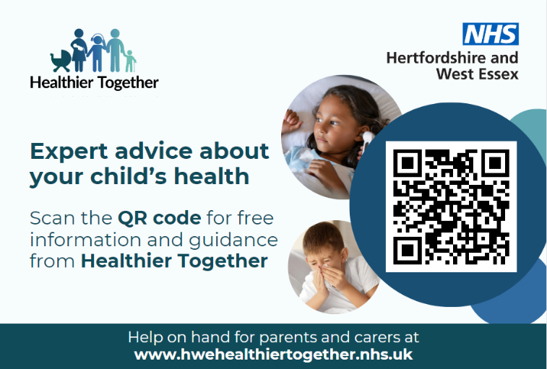

***Posters***

Posters for display in public spaces such as waiting rooms. [Download these posters in full resolution](https://hertsandwestessex.icb.nhs.uk/downloads/download/95/healthier-together-website-promotion) *(please do not save the images directly from this document*).

